CALL FOR PAPERS
THE 2026 JOINT INTERNATIONAL CONFERENCE ON ECONOMIC INTEGRATION AND ENTERPRISE RESILIENCE (CIECI & ICFBE 2026)
Reshaping Integration and Enterprise Resilience: Artificial Intelligence, Supply Chains, Trade and Family Business Governance
22nd - 23rd October 2026 - Hanoi, Vietnam

The University of Economics and Business, Vietnam National University - Hanoi (VNU-UEB), in a strategic partnership with President University (Indonesia), announces the JOINT INTERNATIONAL CONFERENCE ON ECONOMIC INTEGRATION AND ENTERPRISE RESILIENCE (CIECI & ICFBE 2026). This joint event brings together the 14th annual International Conference on International Economic Cooperation and Integration (CIECI 2026) and the 9th International Conference on Family Business and Entrepreneurship (ICFBE 2026).
This year's joint conference aims to explore how artificial intelligence, the restructuring of global supply chains, the establishment of new trade governance frameworks, and the dynamics of family enterprises can help economies respond to and build resilience amidst geopolitical fragmentation. The conference is organized in collaboration with the University of Adelaide (Australia), Confab 360 Degree (India), Sofia University St. Kliment Ohridski (Bulgaria), Rangsit University (Thailand), Foreign Trade University, Diplomatic Academy of Vietnam, University of Economics and Law - VNU HCMC, University of National and World Economy (Bulgaria), and School of Interdisciplinary Sciences and Arts, Vietnam National University - Hanoi (VNU-SIS).
This 1.5-day hybrid conference, to be held on 22-23 October 2026 in Hanoi, will provide a dynamic platform for scholars, researchers, policymakers, and business leaders to exchange ideas, foster meaningful dialogue, share best practices, and develop actionable solutions to lead the way toward a more resilient and sustainable future amid digital transformation and global economic shifts.
- RATIONALE
The global economy stands at a critical crossroads, characterized by a profound paradox. While technological advancements are driving unprecedented levels of digital interconnectedness, geopolitical fractures are simultaneously causing severe physical and institutional fragmentation.
At the forefront of this digital acceleration is the explosive growth of Artificial Intelligence (AI). Generative AI and advanced digital technologies are no longer mere operational tools; they are fundamentally altering global comparative advantages, disrupting traditional labor markets, and accelerating cross-border digital trade. This rapid evolution necessitates an urgent academic and policy discourse on data sovereignty, digital equity, and the establishment of robust frameworks for AI governance in international trade.
Conversely, the physical realm of global trade faces mounting headwinds. Escalating geopolitical tensions, ranging from major power competition to volatile regional conflicts, have exposed the severe fragility of global supply chains. The overarching paradigm has abruptly shifted from “just-in-time” efficiency to “just-in-case” resilience. Consequently, concepts like “Friend-shoring”, “Near-shoring” and “De-risking” are rapidly rewiring global value chains. These shifts pose complex challenges for multinational corporations while simultaneously creating strategic windows of opportunity for emerging economies to upgrade their positions within the new global architecture.
In this deeply fragmented landscape, traditional trade institutions are under immense strain. There is a pressing demand for “New Trade Governance”, innovative and adaptive regulatory frameworks capable of managing the complex nexus of national economic security, digital trade, and sustainable development. As nations navigate non-traditional protectionist barriers and strive to maximize the benefits of new-generation Free Trade Agreements (FTAs) like the CPTPP, EVFTA, and RCEP, formulating resilient institutional responses is critical to preventing a backslide into economic isolationism.
Amidst these macroeconomic and geopolitical shifts, the micro-foundations of enterprise development - particularly family-owned firms and SMEs in emerging economies - play an indispensable role. As global markets face fragmentation and technological disruption, these enterprises remain central actors in driving innovation, employment creation, and long-term value generation. Therefore, understanding how family enterprises and entrepreneurial ventures balance continuity with structural transformation, through strategic governance and succession planning, is vital for holistic regional growth.
The 2026 Joint International Conference on Economic Integration and Enterprise Resilience (CIECI & ICFBE 2026) is convened to untangle this complex interdependence between macroeconomic integration and micro-level enterprise adaptability. By bringing together scholars, researchers, policymakers, and business leaders from around the globe, the conference aims to identify actionable strategies to reshape international economic integration, strengthen corporate resilience and forge pathways toward a more resilient, adaptive, and secure global economy in an era of profound transformation.
- KEY TOPICS
We invite submissions that explore theoretical, empirical, and policy-oriented aspects related to the joint conference themes. To ensure a comprehensive exploration of both macroeconomic trends and micro-level enterprise dynamics, the conference tracks are structured into two main pillars:
TRACK A: Global Integration, Trade Governance & Digital Infrastructure (CIECI Focus)
I. Artificial Intelligence and Digital Trade Governance
- The impact of Generative AI and advanced technologies on global comparative advantages.
- Developing robust regulatory frameworks and governance mechanisms for cross-border data flows.
- Evaluating the effectiveness and evolution of e-commerce legal frameworks within new-generation Free Trade Agreements.
- The role of AI in optimizing global logistics, digital supply networks, and trade facilitation.
- Bridging the digital divide: Strategies for emerging economies to leverage digital trade and AI for inclusive growth.
II. Global Supply Chain Restructuring and Resilience
- Analyzing the trends, drivers, and impacts of “Friend-shoring,” “Near-shoring,” and “De-risking” on global value chains.
- Shifts in global Foreign Direct Investment (FDI) flows in the context of post-pandemic recovery and geopolitical fragmentation.
- Strategic opportunities and challenges for developing and emerging economies in upgrading their positions within restructured supply chains.
- Building corporate and national resilience against supply chain disruptions and external macroeconomic shocks.
- The intersection of green transitions, sustainability standards, and the reconfiguration of global supply chains.
III. Economic Integration amidst Geopolitical Fragmentation
- The rise of minilateralism and its implications for the future of the multilateral trading system
- Navigating new forms of non-traditional protectionism, economic sanctions, and emerging trade barriers.
- Formulating and executing trade policies to safeguard national economic security in a volatile global landscape.
- The impact of regional conflicts and great power rivalry on international trade flows and economic cooperation.
- Balancing strategic autonomy with the imperative of continued global economic integration.
IV. FTA Implementation and New Trade Governance
- Evaluating the practical impacts, utilization rates, and early outcomes of mega-regional FTAs (e.g., CPTPP, EVFTA, RCEP).
- Identifying and overcoming institutional bottlenecks and regulatory constraints in FTA implementation.
- Reforming domestic business environments to maximize the benefits of international integration and attract high-quality investments.
- The evolution of "New Trade Governance" rules concerning labor standards, environmental protection, and intellectual property rights.
- Enhancing national economic resilience through strategic FTA networks and proactive international engagement.
TRACK B: Enterprise Governance, Resilience & Entrepreneurship (ICFBE Focus)
V. Family Business Sustainability and Succession Planning
- The role of family-owned firms in driving innovation, employment creation, and long-term value generation in emerging economies.
- Succession planning, generational transitions, and strategies for balancing historical continuity with structural transformation.
VI. Corporate Governance and Strategic Management
- Adapting governance structures, leadership, and strategic decision-making in evolving entrepreneurial settings.
- SME adaptations, resilience strategies, and managing complex stakeholder relationships amidst geopolitical and economic volatility.
VII. Digital Entrepreneurship and Sustainable Innovation
- Adopting emerging technologies, digital platforms, and data-driven business models in resource-constrained environments.
- Developing sustainable business models, green resilience strategies, and promoting responsible entrepreneurship.
VIII. Entrepreneurial Ecosystems, Finance, and Marketing
- Entrepreneurship education, experiential learning, and human capital development in transitioning economies.
- Exploring venture financing, alternative SME funding mechanisms, and entrepreneurial branding in domestic and cross-cultural contexts.
- PUBLICATIONS OPPORTUNITIES
To provide authors with flexible and high-impact publishing options, CIECI and ICFBE 2026 offer TWO distinct publication tracks. Authors can indicate their preferred tracks upon submission.
Track 1: Springer Proceedings indexed in Scopus
Track 2: ISBN Monograph published by Vietnam National University Press, Hanoi
Track 3: Automatic Publication Transfer Policy (Risk-Free Submission)
To encourage scholars to confidently submit their manuscripts to the Scopus track, the Organizing Committee has implemented a supportive transfer policy in Track 3. More specifically, if a manuscript submitted to Track 1 is not accepted for the Springer proceedings, it may be transferred to Track 2 for peer review and publication, subject to the author(s)’ consent. This policy ensures that authors can ambitiously aim for Scopus indexing without the risk of their paper being entirely rejected from the conference's official publications.
- SUBMISSION GUIDELINES
- Manuscript must be written in ENGLISH in academic style, with a maximum of 5000 words (including references and appendix).
- Submission formatting guidelines and template are available on the conference website.
- Conference Website & Submission Portal: TBA
[5] IMPORTANT DATES
No. | Content | Early bird | Regular
1 | Manuscript / Abstract Submission  (Note: Submit a full paper for publication, or an abstract for presentation only) | 15 July 2026 | 27 August 2026
2 | Revision or Rejection Notification | 30 July 2026 | 08 September 2026
3 | Manuscript Revision Submission (after double-blind review) | 15 August 2026 | 18 September 2026
4 | Registration deadline | 22 August 2026 | 22 September 2026
5 | Conference Date | 22-23 October 2026 | - October 2026
[6] CONFERENCE FEE
- The conference fee is payable only after the author has received the official Letter of Acceptance
- Track 1: USD 400 per accepted paper, with a 5% discount for authors from co-organizing institutions or early-bird submissions.
- Track 2: VND 4,000,000 (approximately USD 150) per accepted paper, with a 30% discount for authors from co-organizing institutions or early-bird submissions.
- Presentation Only: USD 50 (Applicable for online or offline presentation; includes a presentation certificate).
- Attendance Only: Free of charge.
- Discounts are not cumulative.
- CONTACTS
For Indonesian and international (non-Vietnamese) participants:
- Ms. Bintang
Mobile: (+62) 852 80649396 Email: bintang.rumapea@president.ac.id
- Ms. Maria
Mobile: (+62) 813 20080511 Email: maria.irsan@president.ac.id

Title: Example of Full Paper Format

Dr. Pham Hoang Linh^{1*}, Dr. Nguyen Duc Anh^{2*}
¹University of Economics and Business, Vietnam National University, Hanoi, Vietnam
² Foreign Trade University, Hanoi, Vietnam
*Corresponding author: phamhoanglinh@vnu.edu.vn
Abstract
A single paragraph of about 300 words maximum. We strongly encourage authors to use the following style of structured abstracts, but without headings: (1) Background: Place the question addressed in a broad context and highlight the purpose of the study; (2) Methods: briefly describe the main methods or treatments applied; (3) Results: summarize the article’s main findings; (4) Conclusions: indicate the main conclusions or interpretations.
Keywords: Please include 4-5 appropriate keywords separated by commas.
1. Introduction
The purpose of the introduction is to arouse the reader’s attention and provide a general overview of the paper.
2. Literature Review
A literature review is a survey of scholarly sources (such as books, journal articles, and theses) related to a specific topic or research question. It is often written as part of a thesis, dissertation, or research paper, in order to situate your work in relation to existing knowledge.
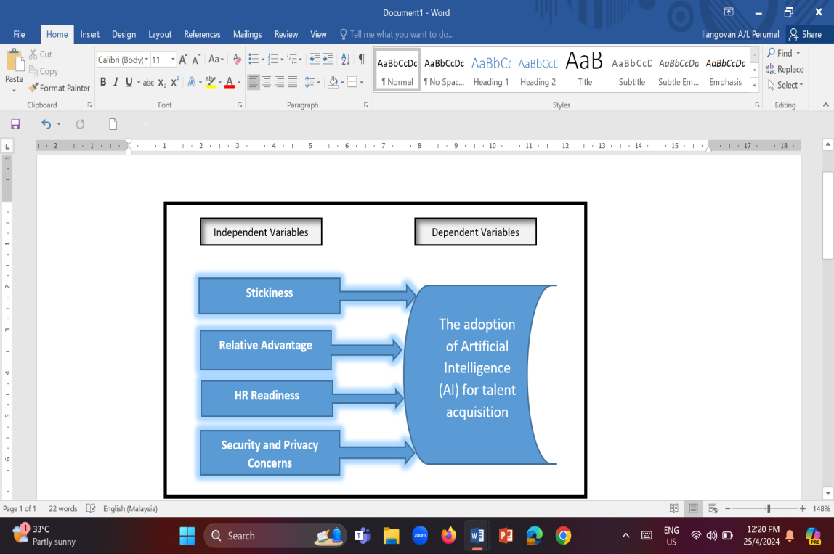
Figure 1. Figure caption
Source: Le Quang Minh (2020)
3. Methodology
This section describes the methodology of the study. It may include sub-sections such as participants, research instruments, data collection, and data analysis.
4. Results and discussions
This section should be organized in order to answer each of your research questions
Table 1: Font size and format of the full paper
No. | Content | Notes
1. | The full paper should be 6000 words maximum including references and appendix
2. | Please use 12-point Times New Roman font and single line spacing for the whole document.
Source: Le Quang Minh (2020)
5. Conclusion and implications
This section should summarize the key findings of the study, highlight their theoretical and practical implications, and provide policy or managerial recommendations. It may also briefly discuss the study’s limitations and suggest directions for future research.
7. References
For citations, please follow the APA style.
- Timothy, D. J., & Nyaupane, G. P. (Eds.). (2009). Cultural Heritage and Tourism in the Developing World: A Regional Perspective. Routledge. https://doi.org/10.4324/9780203877753.
- Tran, N. D., & Bui, H. T. (2023). Tourist satisfaction with heritage site services: A case study of the Temple of Literature in Hanoi. Malaysian Journal of Social Sciences and Humanities, 8(3), 151–160. https://malque.pub/ojs/index.php/msj/article/view/2182

